**Experiment no. 05**

* 1. **Experiment Name**

Fault simulation in integrated AM/FM fault simulation

* 1. **Objectives**
* To get acquainted with the operation of the integrated AM/FM
* To learn about the fault simulated from the color integrated AM/FM
* To understand about the basics of the components of integrated AM/FM and how they work together
  1. **Theory**

An FM/AM fault simulator is a tool that is used to model various types of faults or mistakes that may occur in FM (Frequency Modulation) and AM (Amplitude Modulation) radio receivers. This is used to evaluate the performance and robustness of radio equipment under various fault scenarios without interfering with live broadcast signals. This contributes to the dependability and quality of communication networks.

To analyze how the equipment responds, the simulator may generate a variety of simulated faults and interference conditions. The following are the main attributes and characteristics that can be found in an FM/AM failure simulator:

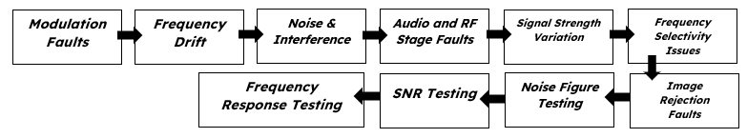

**5.4** **Apparatus**

* Integrated AM/FM
* Multi-meter
* Oscilloscope
  1. **Experimental Setup**

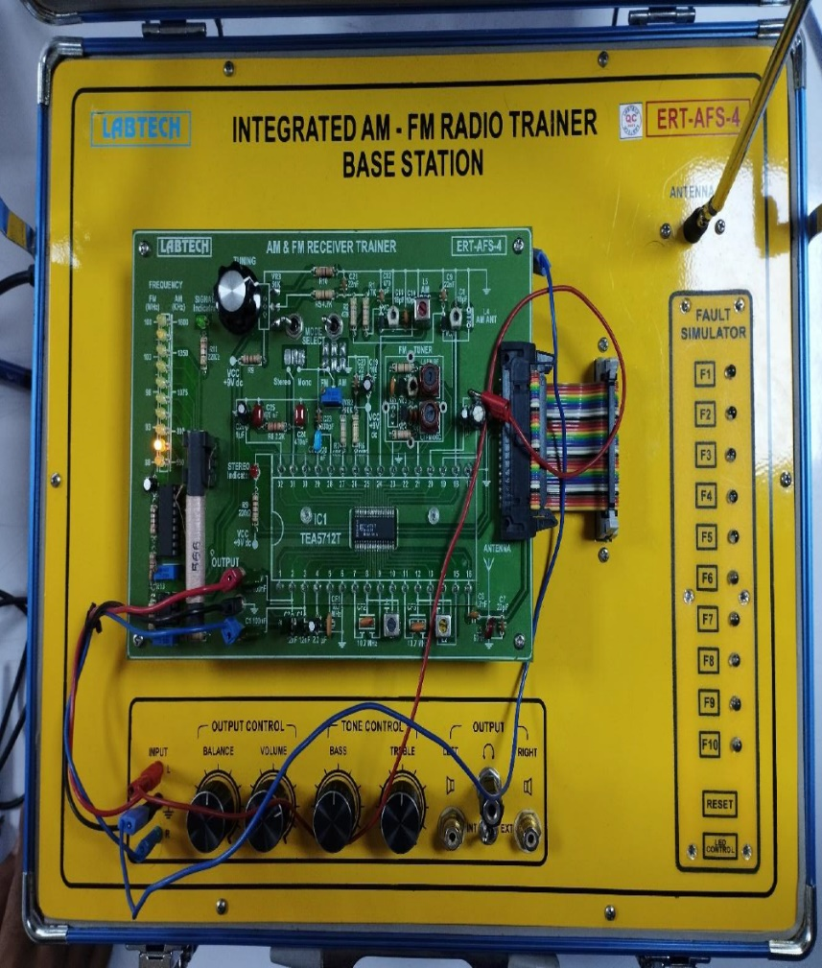 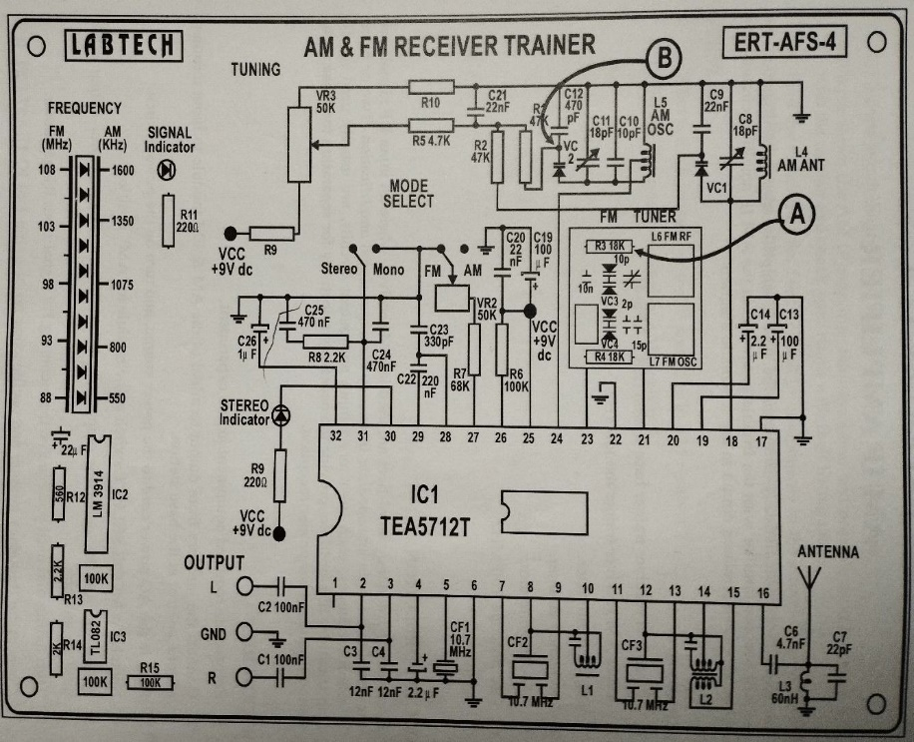

**Fig 5.1 A**M & FM receiver trainer **Fig. 5.2:** Internal Circuit diagram of AM/FM receiver trainer

* 1. **Faults in AM & FM receiver trainer**

|  |  |  |  |  |  |  |  |
| --- | --- | --- | --- | --- | --- | --- | --- |
| **FAULT NO** | **DEFECTIVE CIRCUIT** | **DEFECTIVE COMPONENT** | **SYMPTOM** | **FAULT NO** | **DEFECTIVE CIRCUIT** | **DEFECTIVE COMPONENT** | **SYMPTOM** |
| 1 | DC POWER INPUT | DC POWER LINE | SYSTEM IS NOT WORKING | 6 | AM IF STAGES | L1 | NO AM SIGNAL OUTPUT |
| 2 | STEREO DECODER | R9 | STEREO INDICATOR DOES NOT LIGHT | 7 | AM RF | R2 | WEAK AND NOISES AM SIGNAL |
| 3 | AUDIO OUTPUT | C2 | NO LEFT (L) AUDIO SIGNAL | 8 | AM OSCILLATOR | R1 | CANNOT RECEIVE AM SIGNAL |
| 4 | DETECTOR & MPX | IC1 PIN6 | NOISES AND WEAK SIGNAL OUTPUT | 9 | FM TUNER | R3 | CANNOT RECEIVE FM SIGNAL |
| 5 | FM IF STAGES | CF2 | WEAK FM SIGNAL OUTPUT | 10 | AM AGC | C14 | NO AM SIGNAL OUTPUT |

* 1. **Waveshapes**



**Fig. 5.3.** Output of AM/FM receiver trainer

* 1. **Discussion & Conclusion**

The experiment, according to our theoretical knowledge, was carried out in AM/FM receiver trainer. Step by step, various block and tuning procedures were noticed. The intended signal was then viewed on the oscilloscope.

We witnessed an AM/FM failure simulation that was incorporated. We examined the system's output. Then we used the F1 through F10 keys to generate different types of errors and observe how they influenced the system's output. All of these discussions indicate that the experiment was a success.

We discovered that some errors were properly recreated while others were not because the color television trainer was old. The preceding discussion indicates that the experiment was a success.